Quiz 02
- Consider the following bridge full wave rectifier
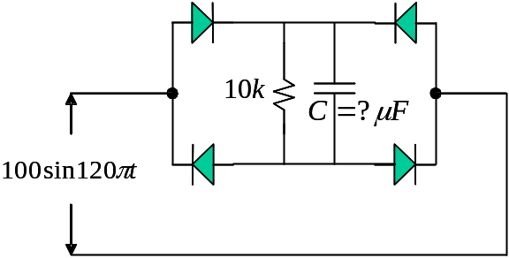

Determiner 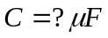 such that the DC ripple 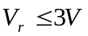
Ans: 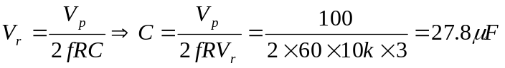
- Consider the following limiter circuit and assume all diodes are ideal
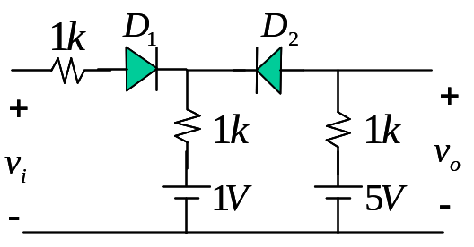

Find the input-output transfer curve.
Ans: (1) let 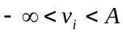 → 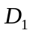 off 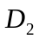 on → 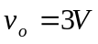
(2) 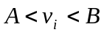 → on on →
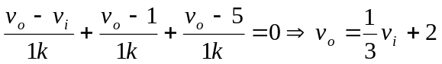
(3) 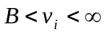 → on off → 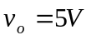
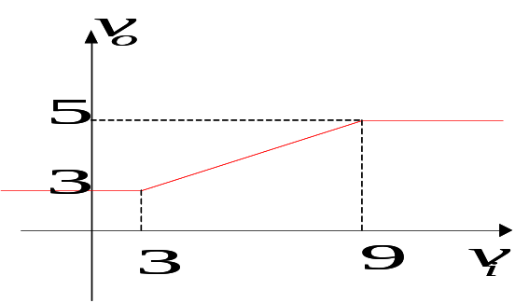
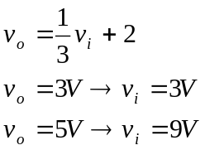

- Consider the following limiter circuit and assume all diodes are ideal
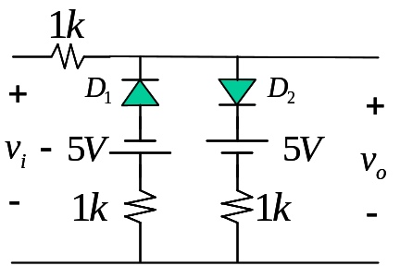

Find the input-output transfer curve.
Ans: (1) let 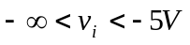 → on off →
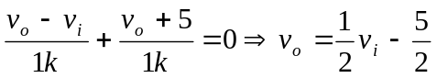
(2) 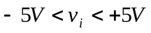 → off off → 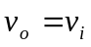
(3) 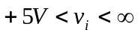 → off on →
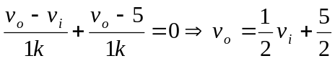
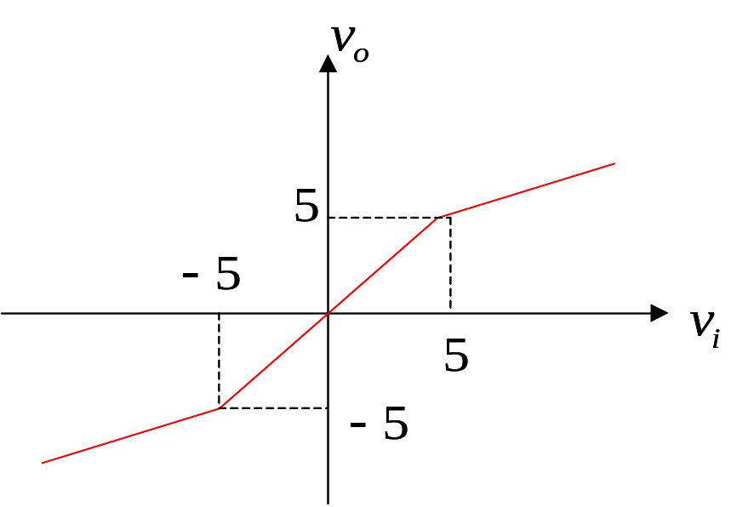
- Consider the following Zener diode circuit
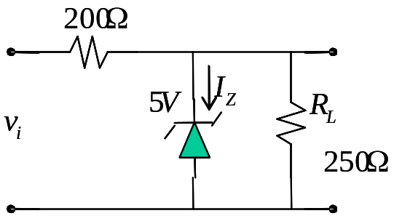

Let 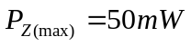 and 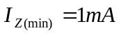, find the range of 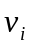 such that .
Ans: 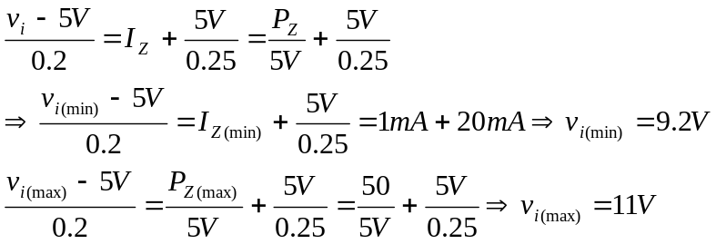
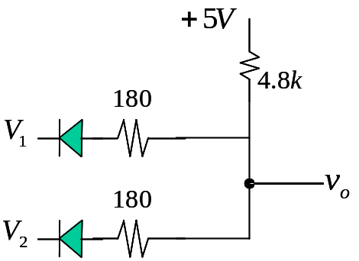
- For the following circuit, the diode has 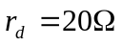, 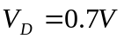. Find 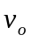 for the case of 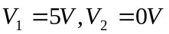

Ans: only D2 diode on, 